**Problem 1**

Model Summary:

**RNN with Word2Vec**

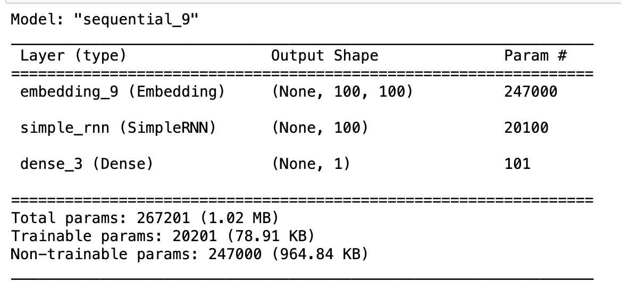

### LSTM with Word2Vec

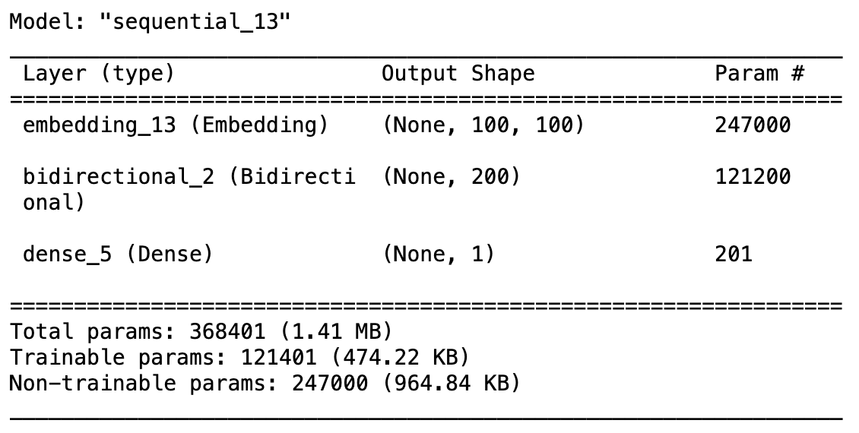

### GRU with Word2Vec -

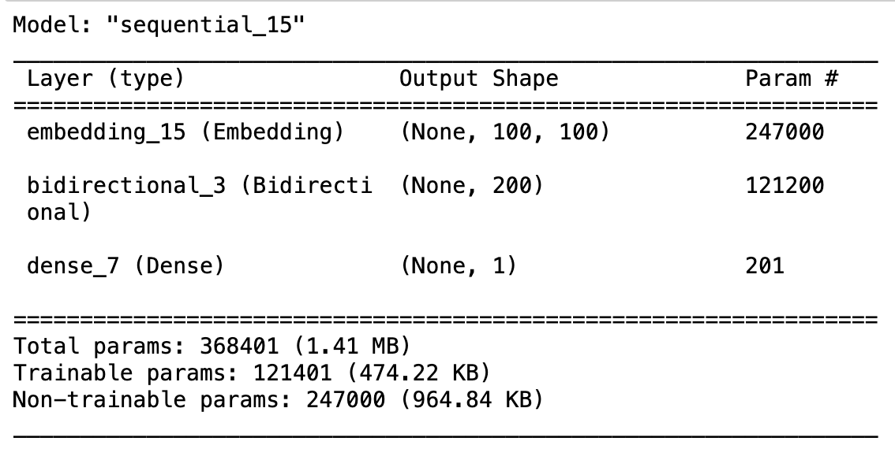



### RNN with GloVe

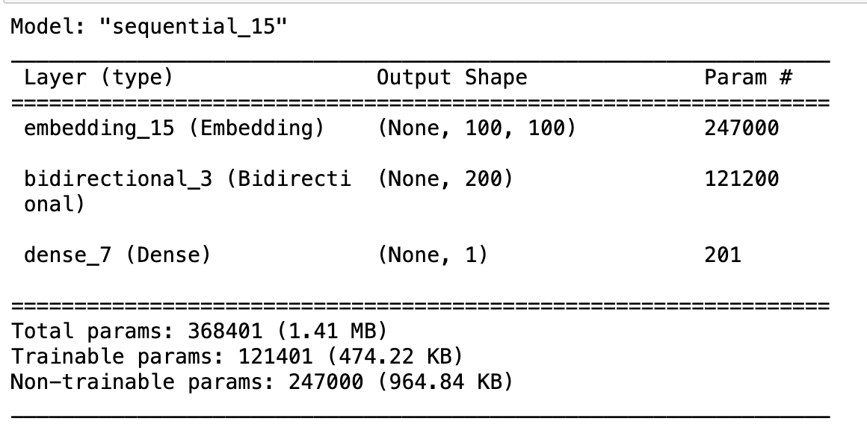

### LSTM with GloVe

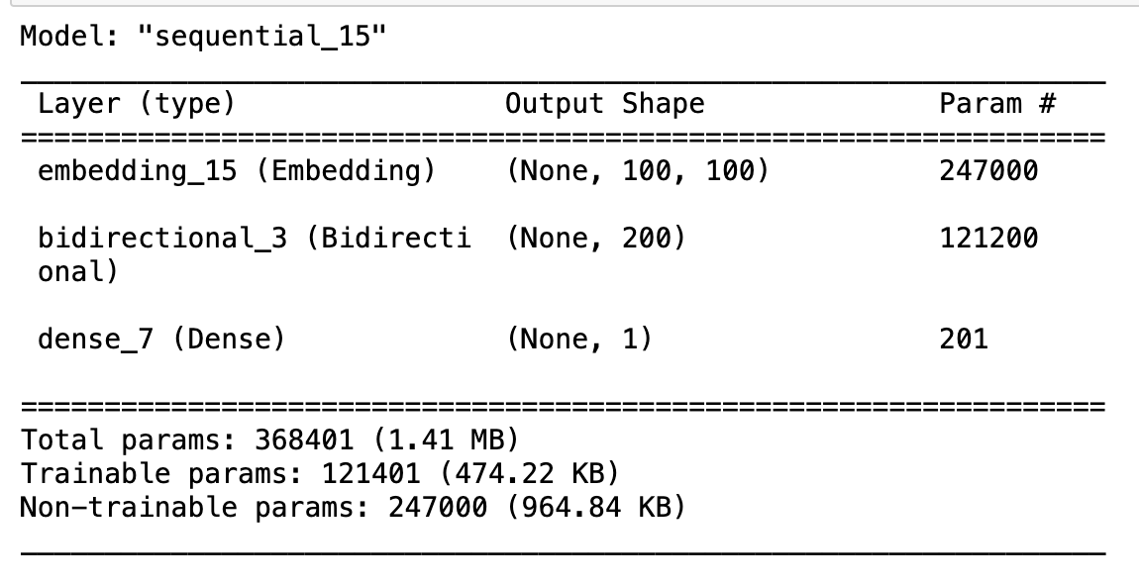



### GRU with GloVe

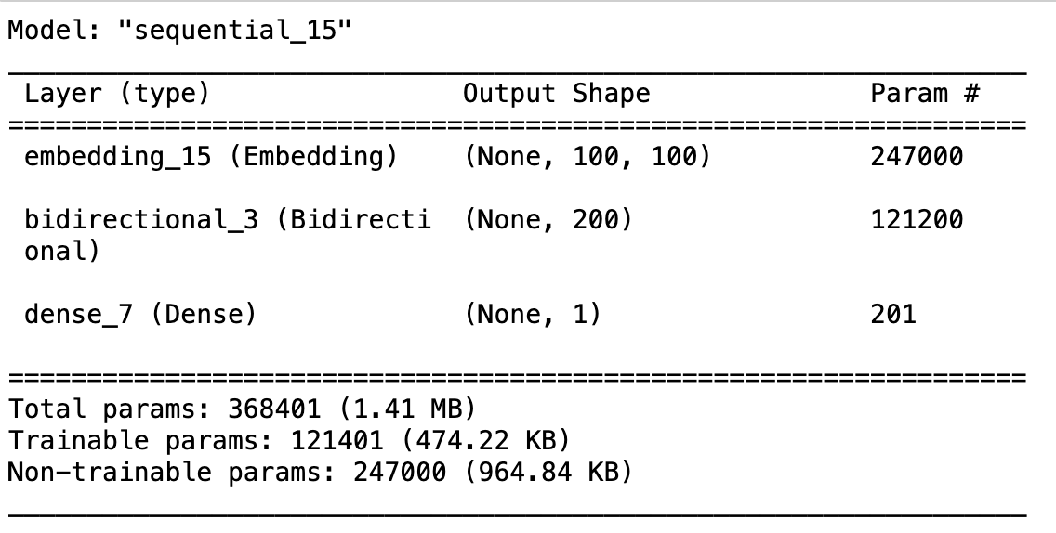



|  |  |
| --- | --- |
| **Model** | **Epochs** |
| Word2Vec - RNN | 10 |
| Word2Vec - LSTM | 10 |
| Word2Vec - GRU | 5 |
| GloVe - RNN | 5 |
| GloVe - LSTM | 5 |
| GloVe - GRU | 10 |

The below applies for all model and embedding combinations:

Learning Rate - Default

Metric – Accuracy

Activation (Hidden ) – Tanh

Activation (Output) – Sigmoid

Weight Initializer – Glorot

Hidden Layers – 1

Neurons in Hidden Layers – 100

Loss Function – Binary Cross Entropy

Optimizer - Adam

The best performing combination was **Word2Vec with RNN and GRU**, **LSTM** and **GRU with GloVe** with Accuracy **87.99%, 87.54%, 86.34%.**

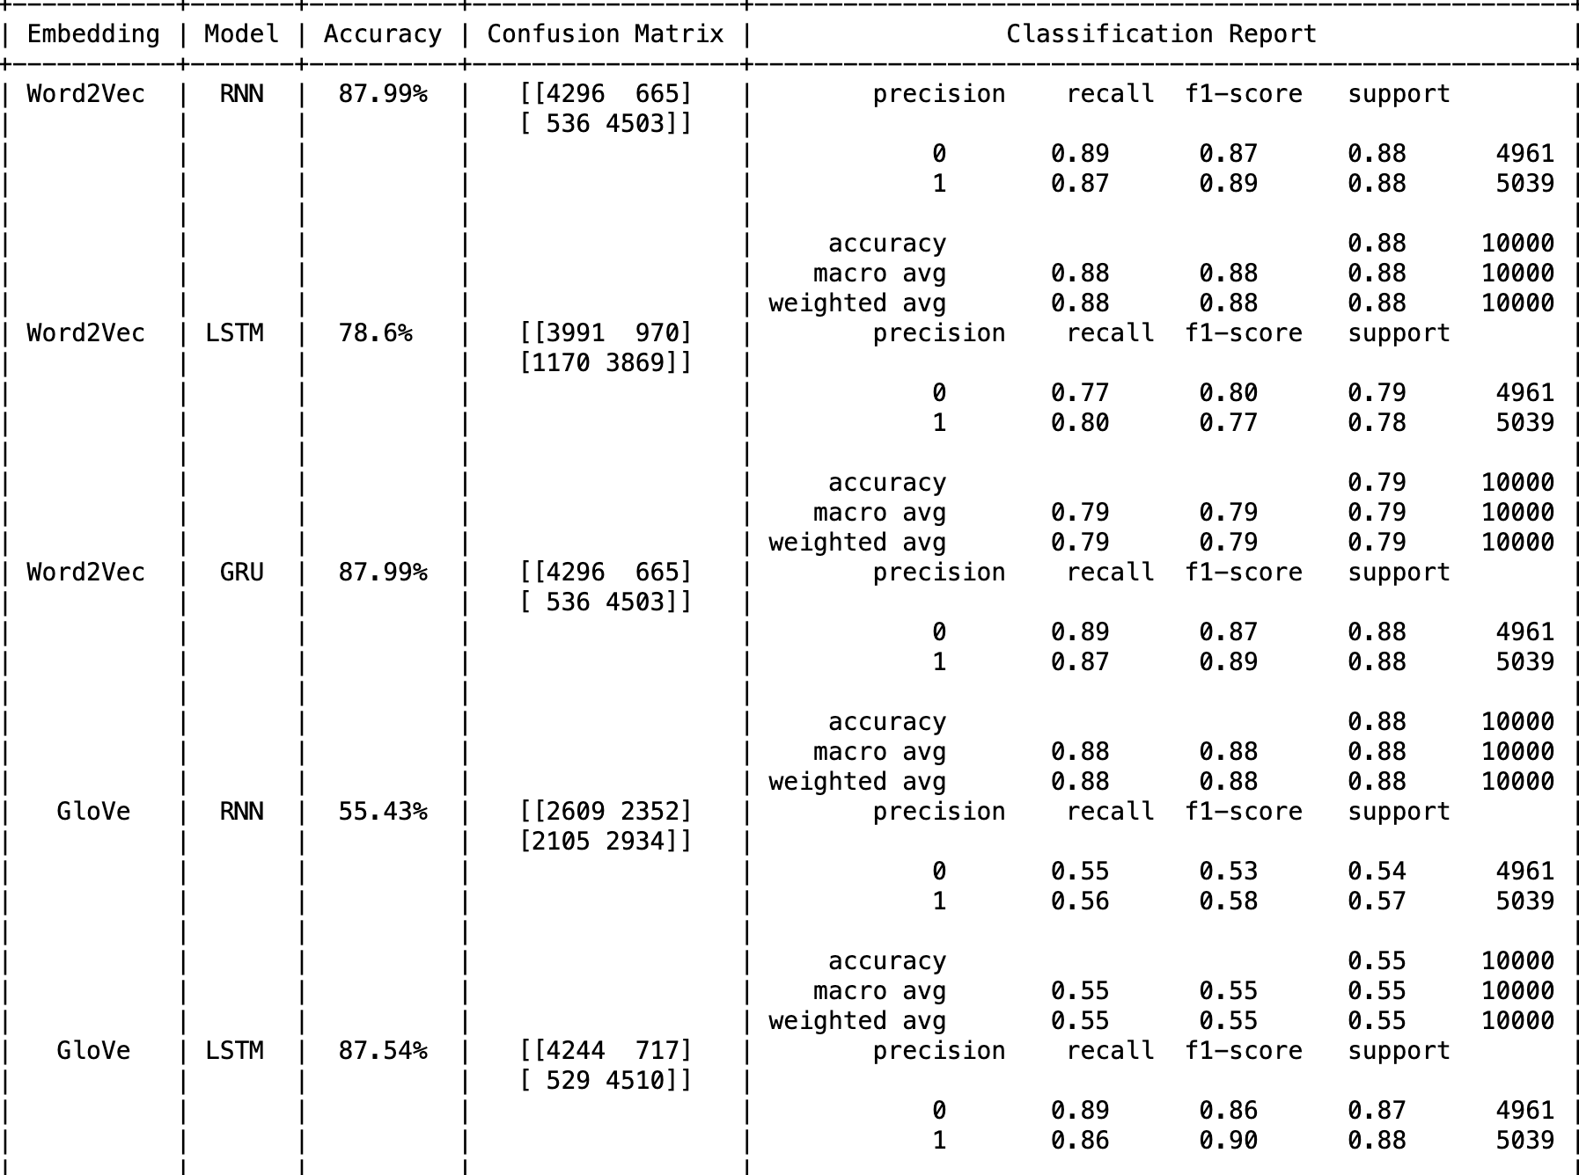

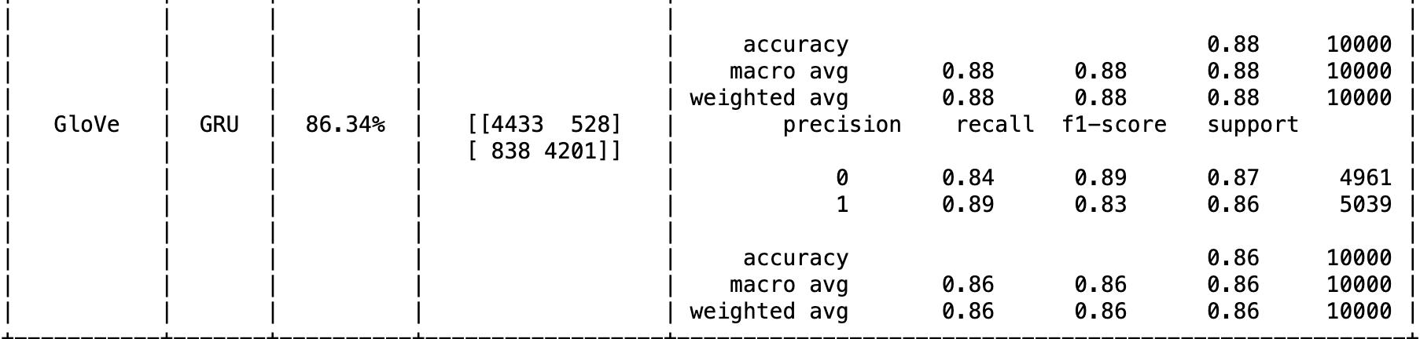

**Problem 2**

Text generation model:

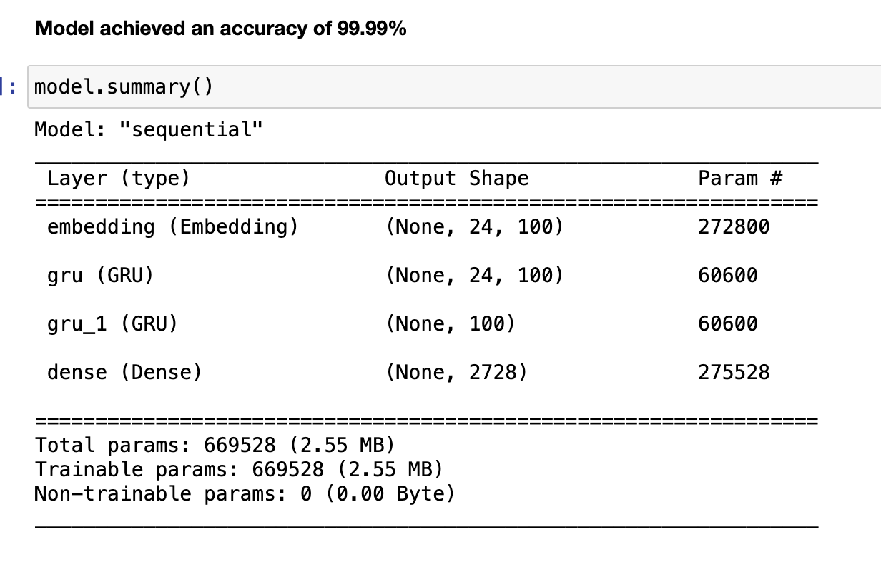

|  |  |
| --- | --- |
| **Hyperparameter** | **Value** |
| Activation Function (Hidden) | Linear for Embedding, Tanh for GRU |
| Activation (Output) | SoftMax |
| Weight Initializer | Uniform |
| Hidden Layers | 2 |
| Neurons in Hidden Layer | 100 |
| Loss Function | Categorical Cross entropy |
| Optimizer | Adam |
| Epochs | 60 |
| Evaluation Metric | Accuracy |

### Transfer learning: (word2vec word embeddings)

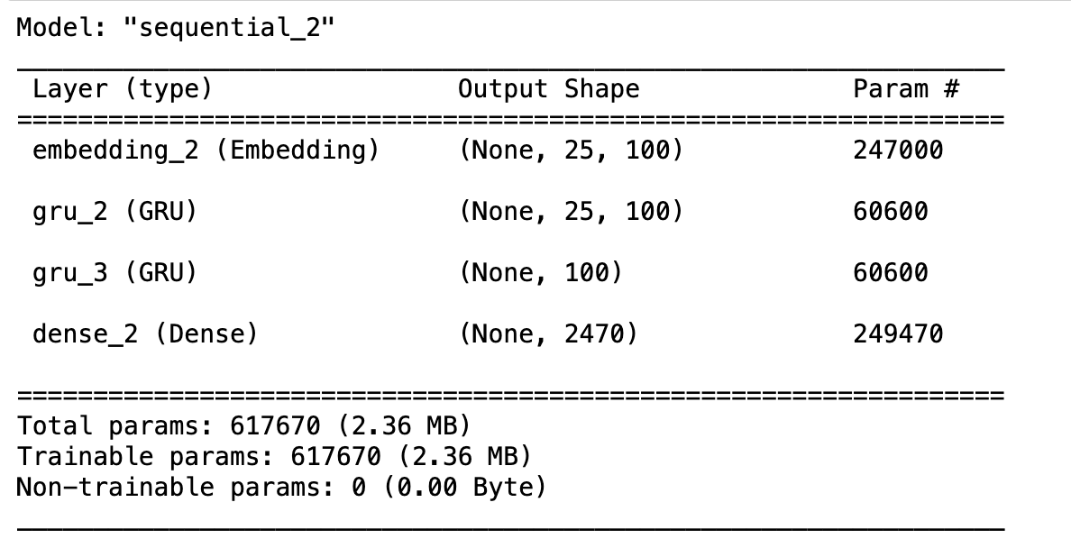

|  |  |
| --- | --- |
| **Hyperparameter** | **Value** |
| Activation Function (Hidden) | Tanh for LSTM |
| Activation (Output) | SoftMax |
| Weight Initializer | Uniform |
| Hidden Layers | 1 (LSTM Layer) |
| Neurons in Hidden Layer | 100 |
| Loss Function | Categorical Cross entropy |
| Optimizer | Adam |
| Epochs | 50 |
| Evaluation Metric | Accuracy |